**Desktop Frame**

<https://www.figma.com/proto/j4aIwuAR7zHt6Zyp8h2XjC/Untitled?node-id=24-3666&t=Jq4xU8bZVjtfxpET-1>

**Mobile Frame (iPhone 14&15 pro max)**

<https://www.figma.com/proto/j4aIwuAR7zHt6Zyp8h2XjC/Untitled?node-id=429-2865&t=Jq4xU8bZVjtfxpET-1>

**Tab Frame (ipad mini 8.3)**

<https://www.figma.com/proto/j4aIwuAR7zHt6Zyp8h2XjC/Untitled?node-id=636-3166&t=Jq4xU8bZVjtfxpET-1>

**Project Overview**

The goal of this project was to design an intuitive, visually appealing, and user-friendly UI for an electronic store website. The design includes both admin-side and user-side pages, ensuring a seamless experience for both administrators and customers. The design was created using Figma with a strong focus on optimizing the user interface for desktop devices. While the primary emphasis was on delivering an exceptional desktop experience, the design also takes into account varying desktop screen sizes, ensuring that the layout remains consistent, accessible, and visually pleasing across different resolutions. This desktop-first approach ensures that users on larger screens have an engaging and efficient experience, tailored specifically to their needs.

**Desktop Frame**

**Design Choices**

**Admin Side Pages**

**Dashboard Page**

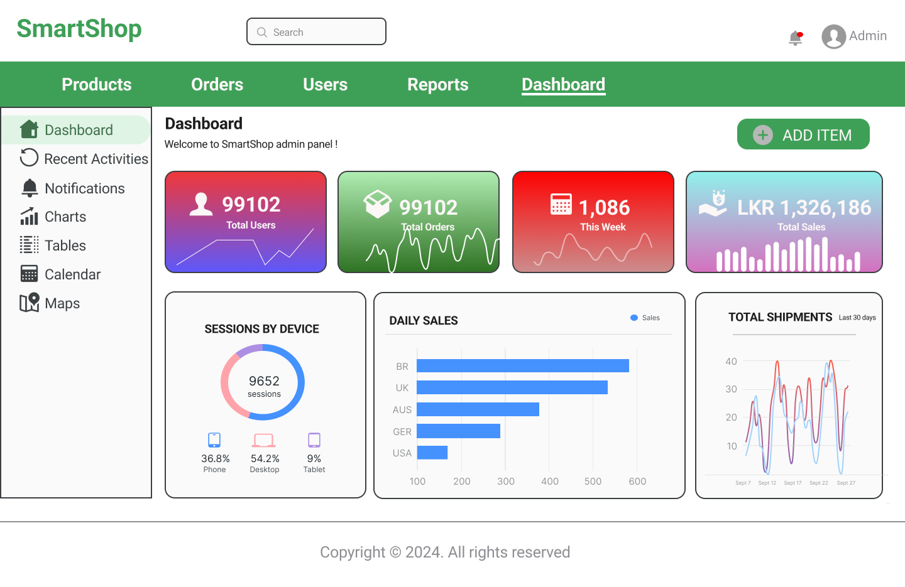

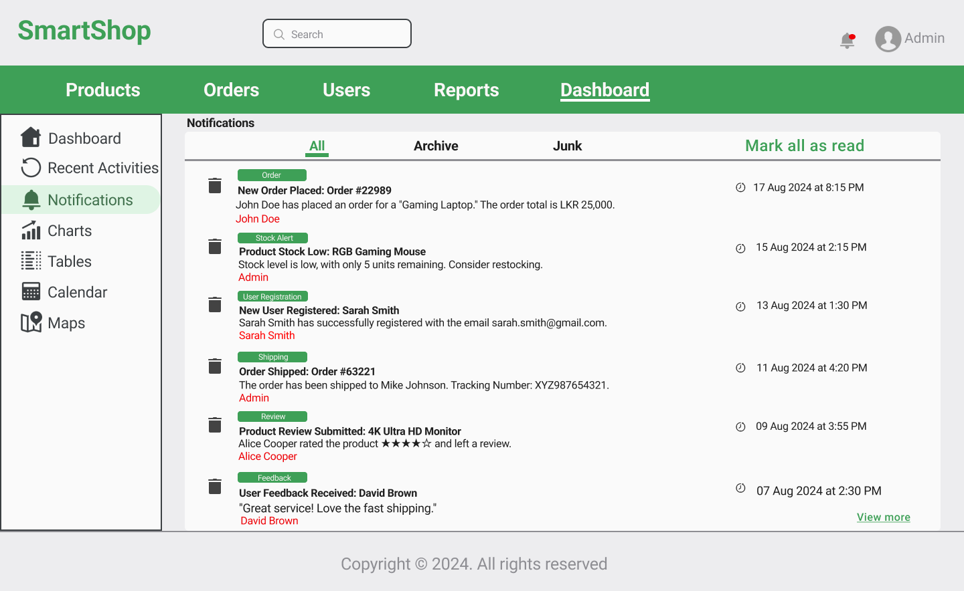

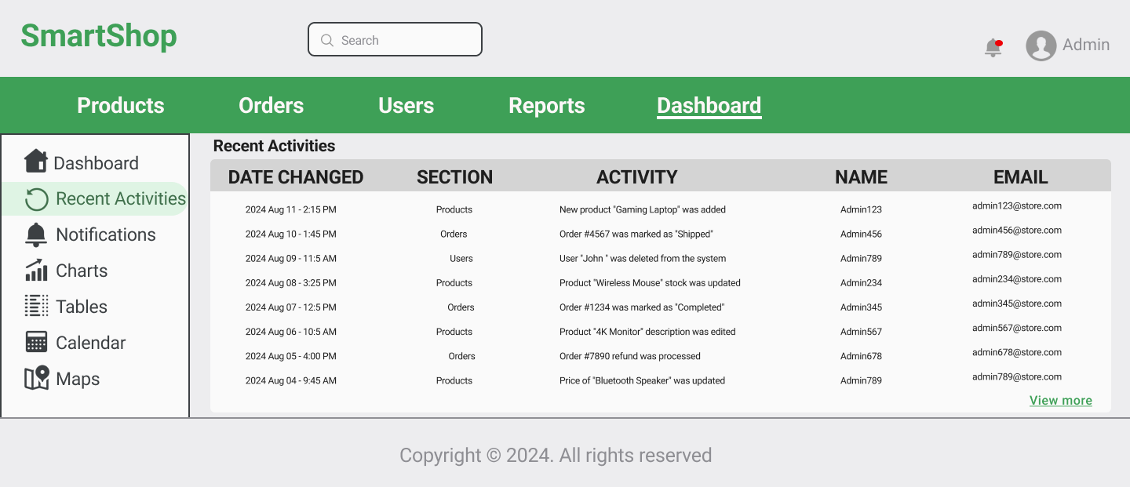

**Design:** The dashboard provides a summary of key statistics (total sales, orders, users) and recent activities. It features quick links to major sections such as Products, Orders, Users, and Reports for efficient navigation.

**Choice Rationale:** A clean, organized layout allows admins to quickly access important information and manage tasks efficiently.

**Product Management Page**

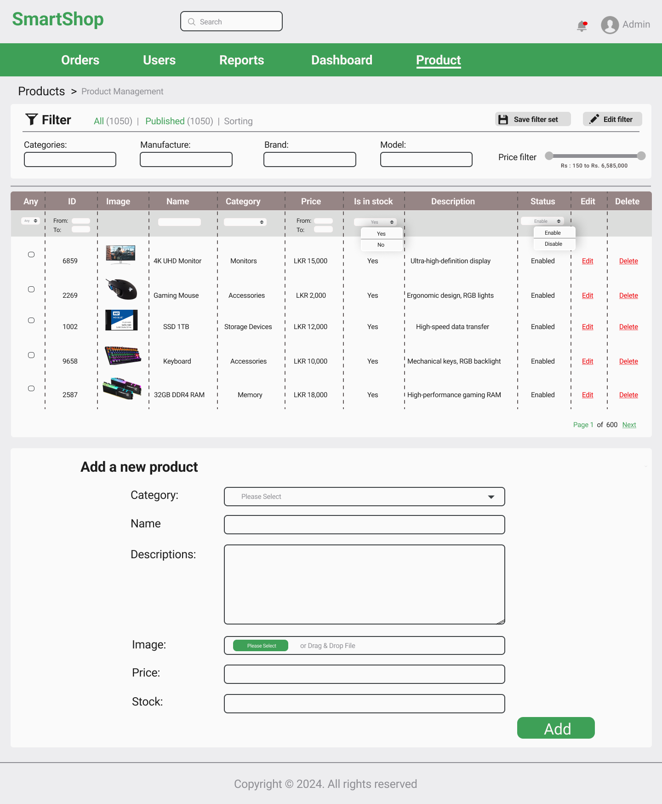

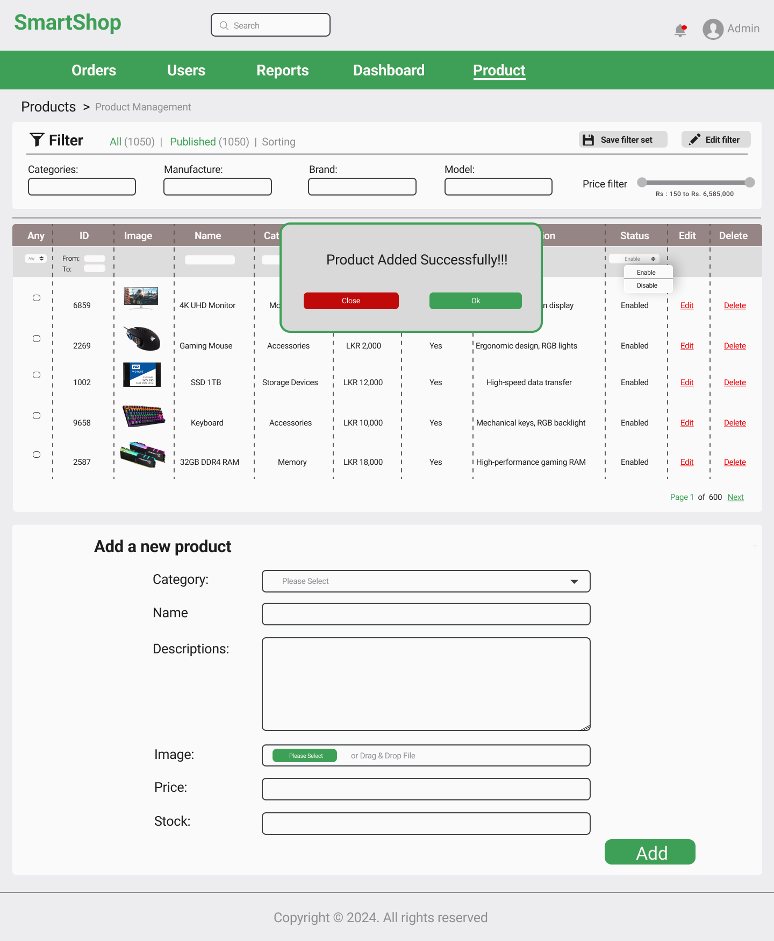

**Design:** Displays a list of products with options to add, edit, or delete items. Includes product details such as name, category, price, stock, description, and images, with integrated search and filter functionalities.

**Choice Rationale:** Easy product management through a straightforward interface ensures that admins can handle product information effectively.

**Order Management Page**

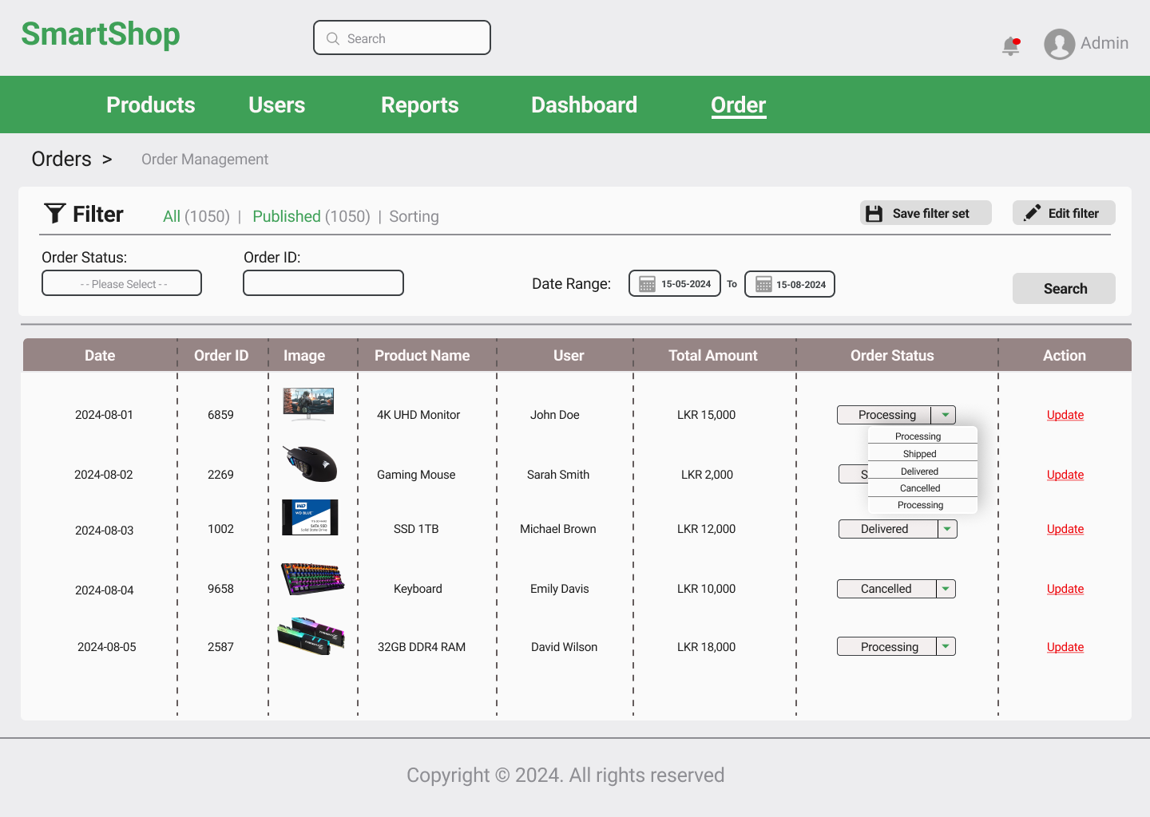

**Design:** Lists all orders with details like order ID, user, date, status, and total amount. Features functionalities for updating order status and includes search and filter options.

**Choice Rationale:** Simplifies order tracking and management by providing a detailed view and easy status updates.

**User Management Page**

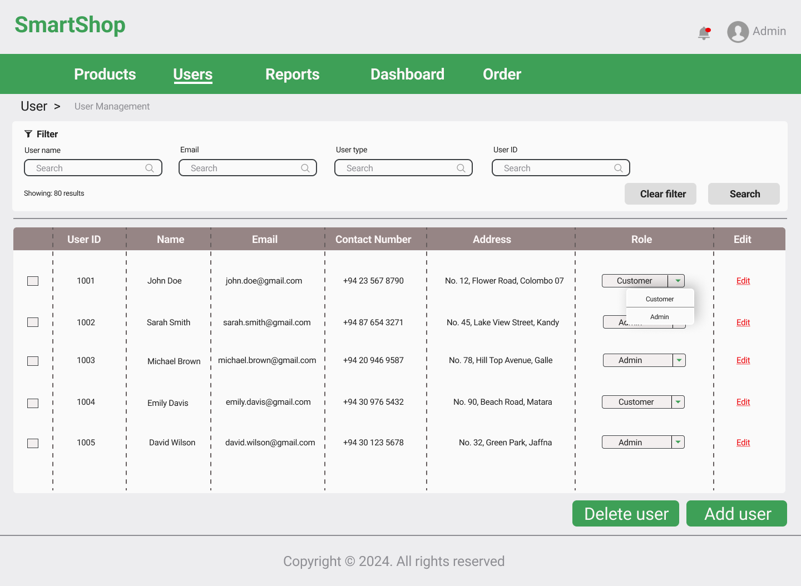

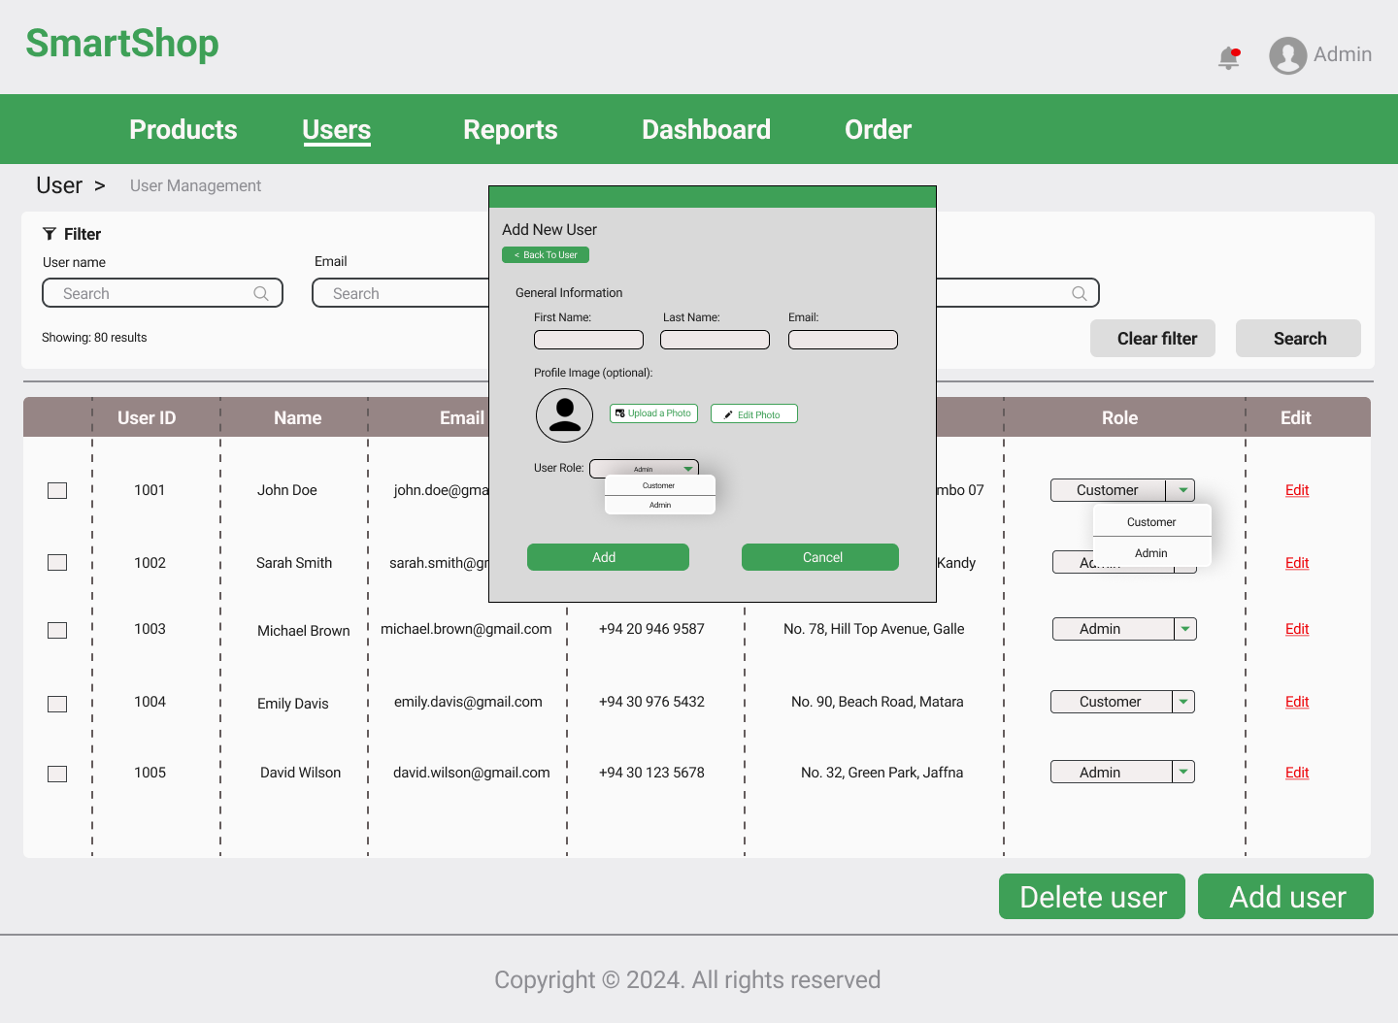

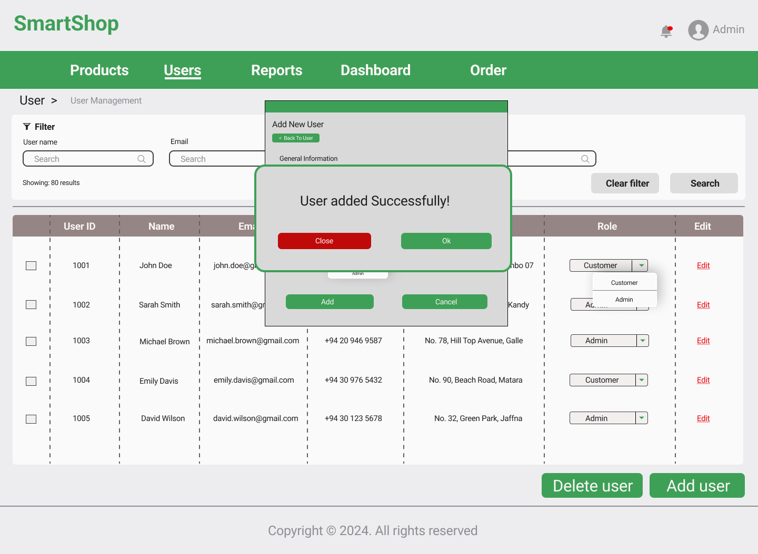

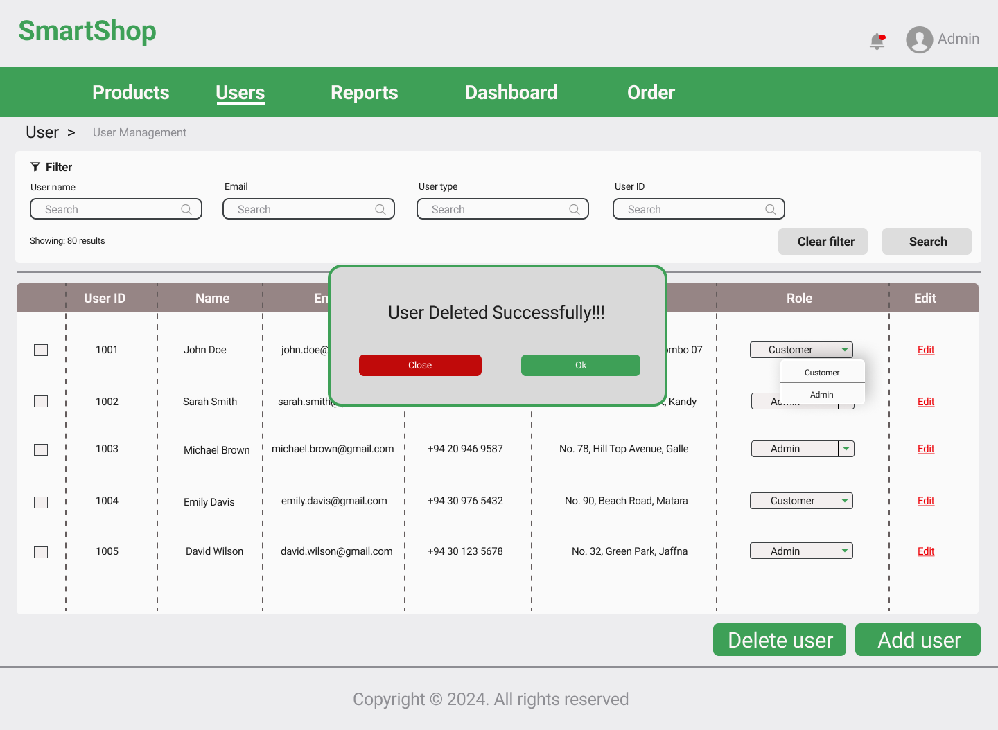

**Design:** Shows a list of users with their details and options to add, edit, or delete users. Includes user role management functionalities (admin, customer).

**Choice Rationale:** Facilitates efficient user management and role assignment, contributing to better system administration.

**Reports Page**

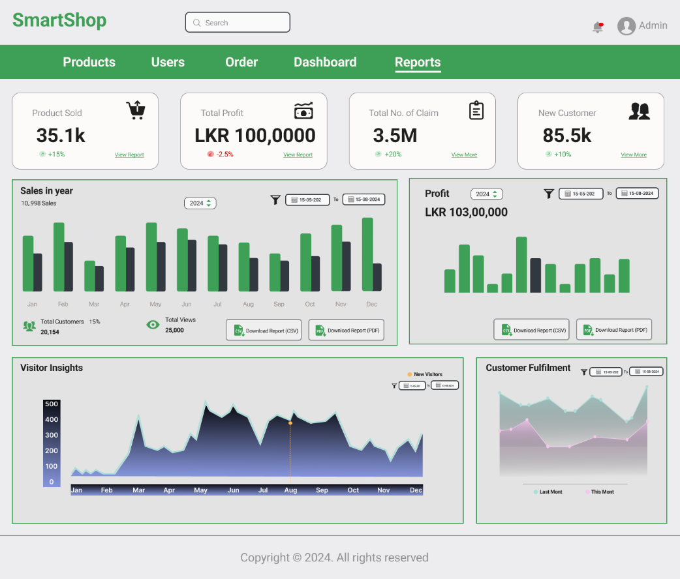

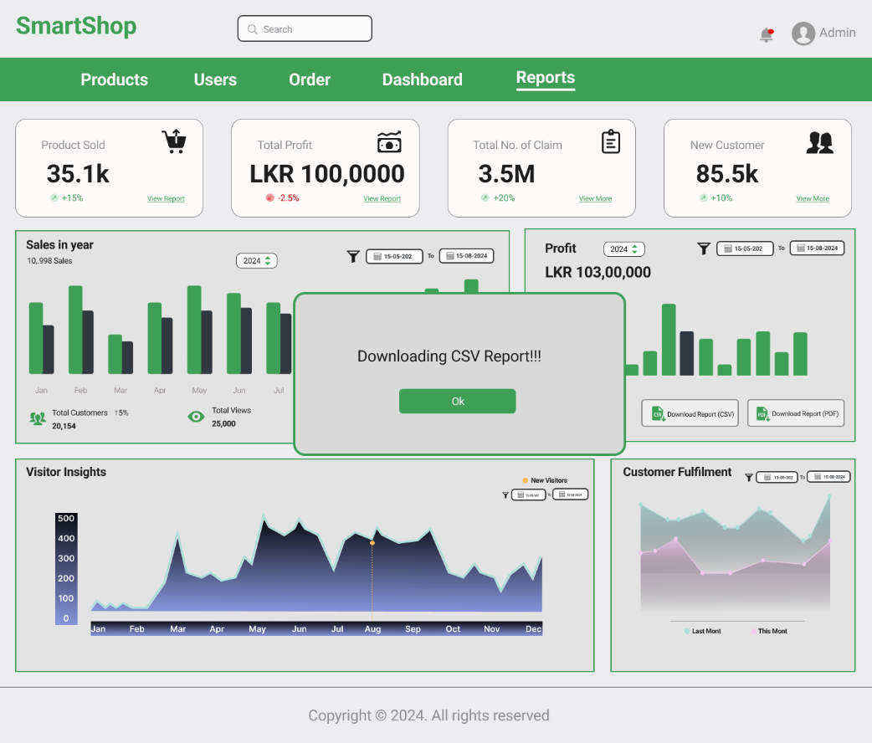

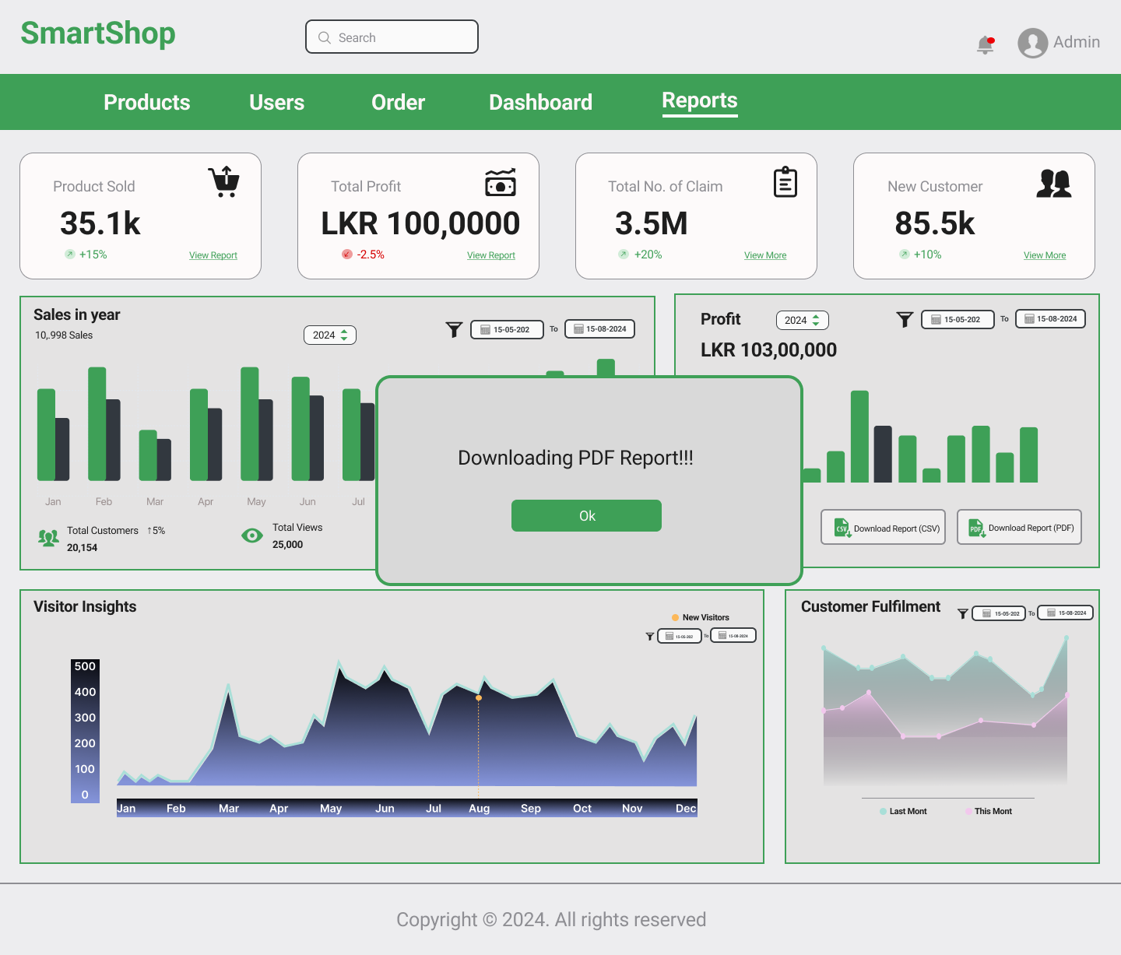

**Design:** Presents sales reports with charts and graphs. Includes a date range filter and options to download reports in various formats (PDF, Excel).

**Choice Rationale:** Provides comprehensive sales analysis and flexible reporting options to meet various administrative needs.

**User Side Pages**

**Home Page**

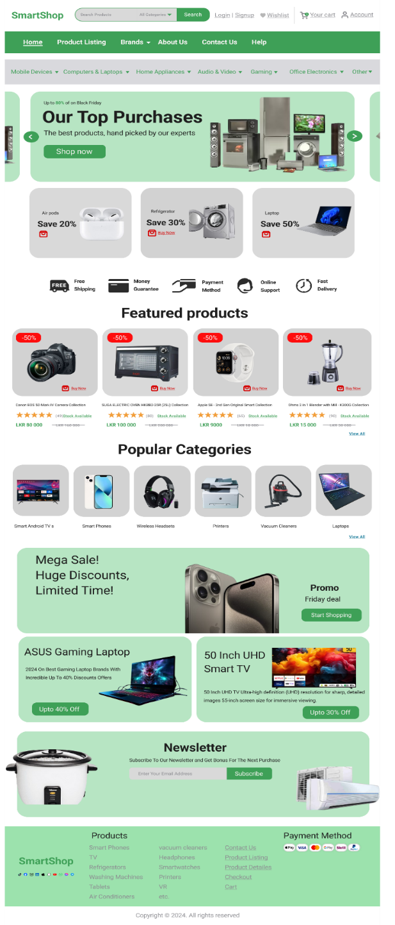

**Design:** Features highlighted products and categories, special offers, and banners. Ensures user-friendly navigation to other sections of the site.

**Choice Rationale:** Attracts users with prominent offers and easy access to key areas of the site.

**Product Listing Page**

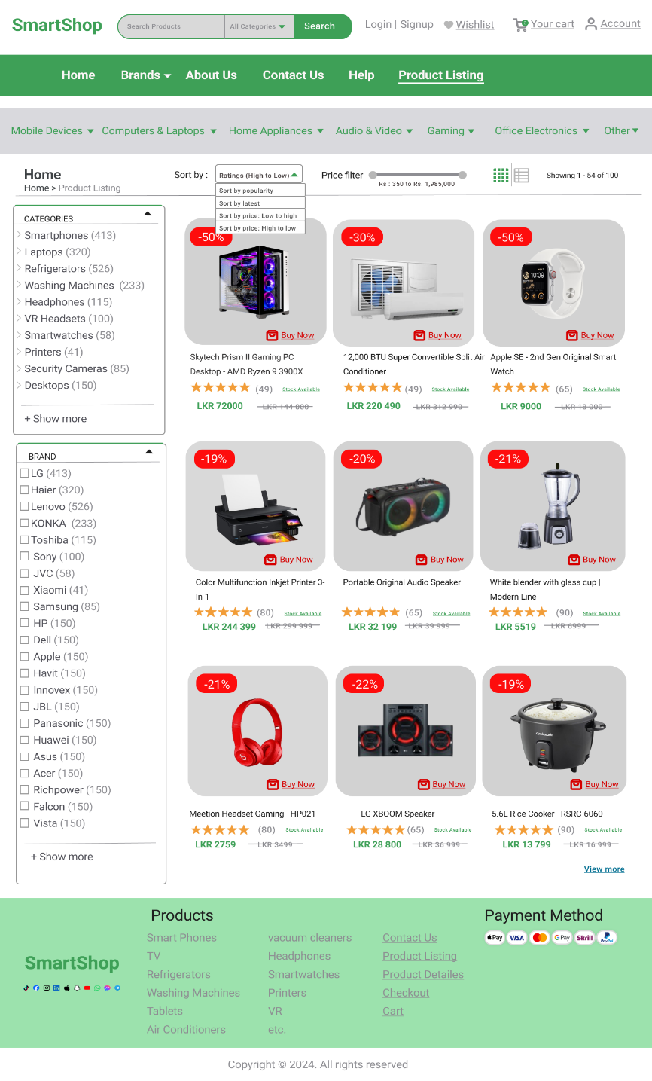

**Design:** Lists products with options for filtering (price, category, brand, rating), grid and list view toggles, and sorting options (price, newest, etc.).

**Choice Rationale:** Enhances user experience by providing flexible product browsing and sorting options.

**Product Details Page**

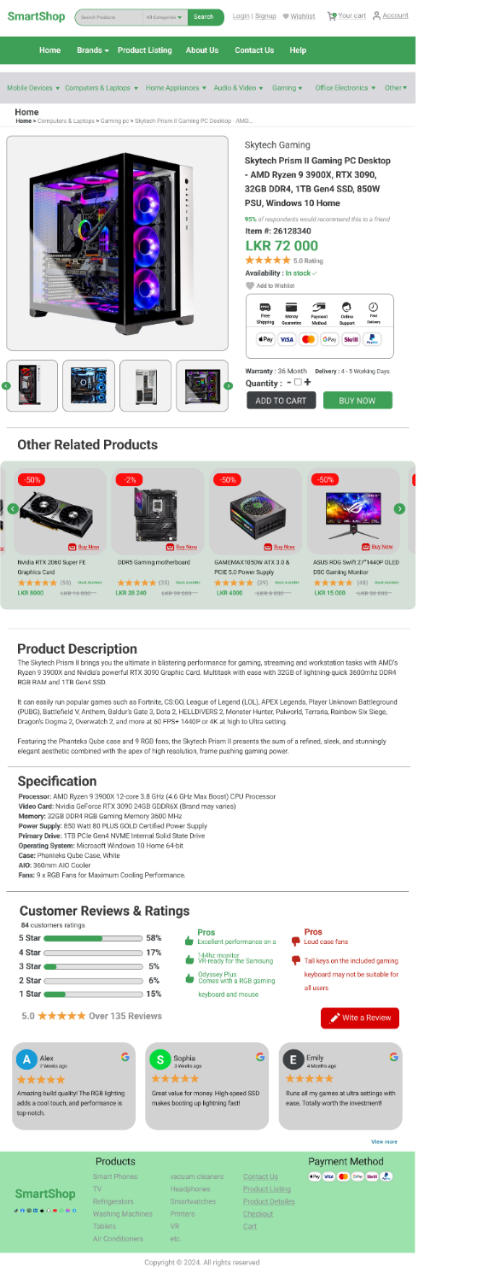

**Design:** Shows detailed product information including images, description, specifications, and reviews. Includes functionalities for adding items to the cart and wish list, and a section for related products.

**Choice Rationale:** Offers a comprehensive view of product details to aid in informed purchasing decisions.

**Shopping Cart Page**

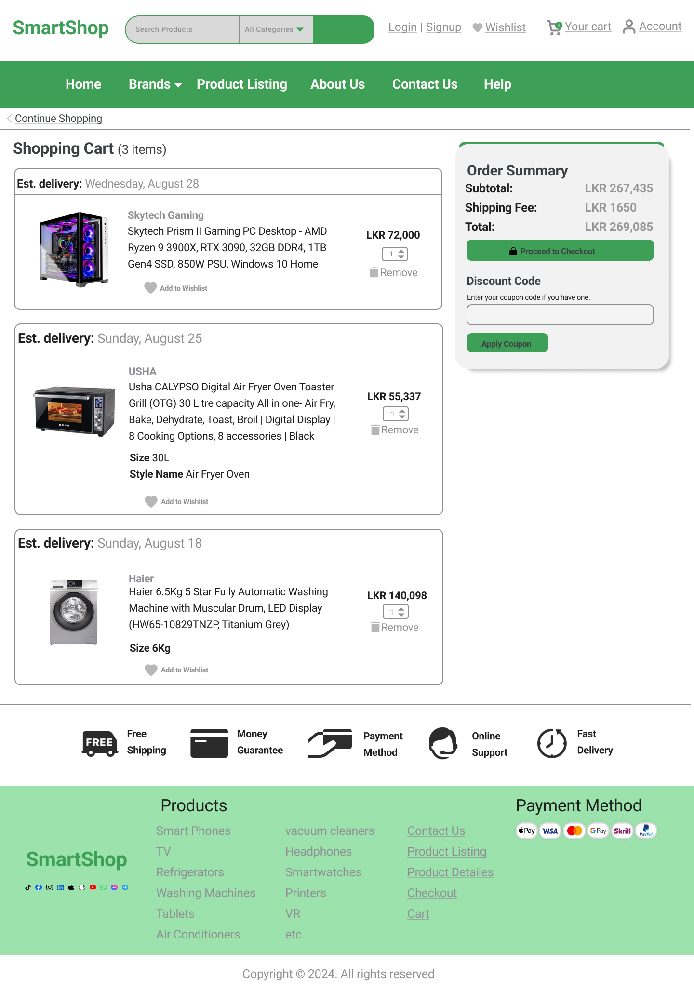

**Design:** Displays items in the cart with options to update quantities or remove items. Shows the estimated total price and a checkout button.

**Choice Rationale:** Provides a clear view of the shopping cart and facilitates an easy checkout process.

**Checkout Page**

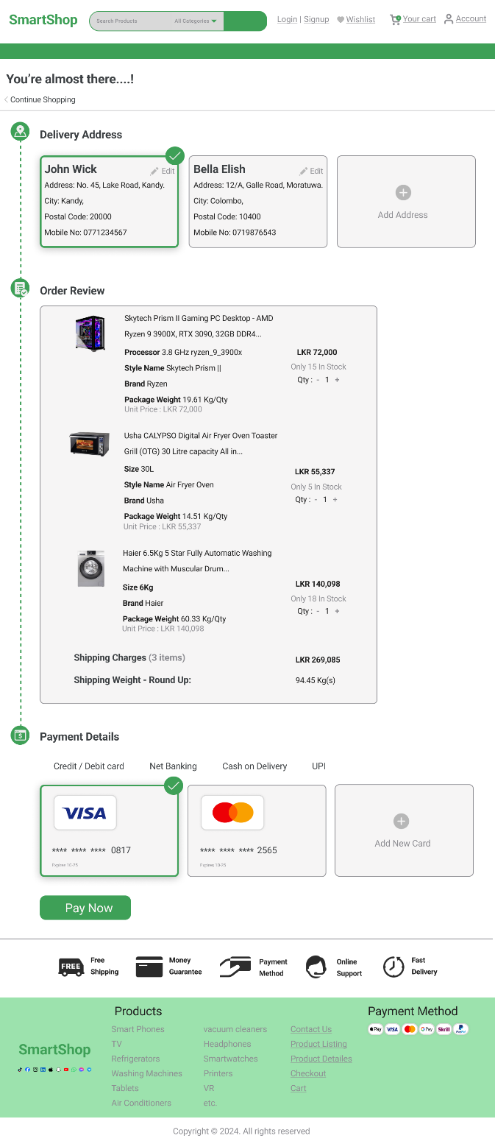

**Design:** Collects user address and payment information, with an order summary and place order button. Includes a confirmation message with order details.

**Choice Rationale:** Streamlines the checkout process and provides confirmation to enhance user trust and satisfaction.

**User Profile Page**

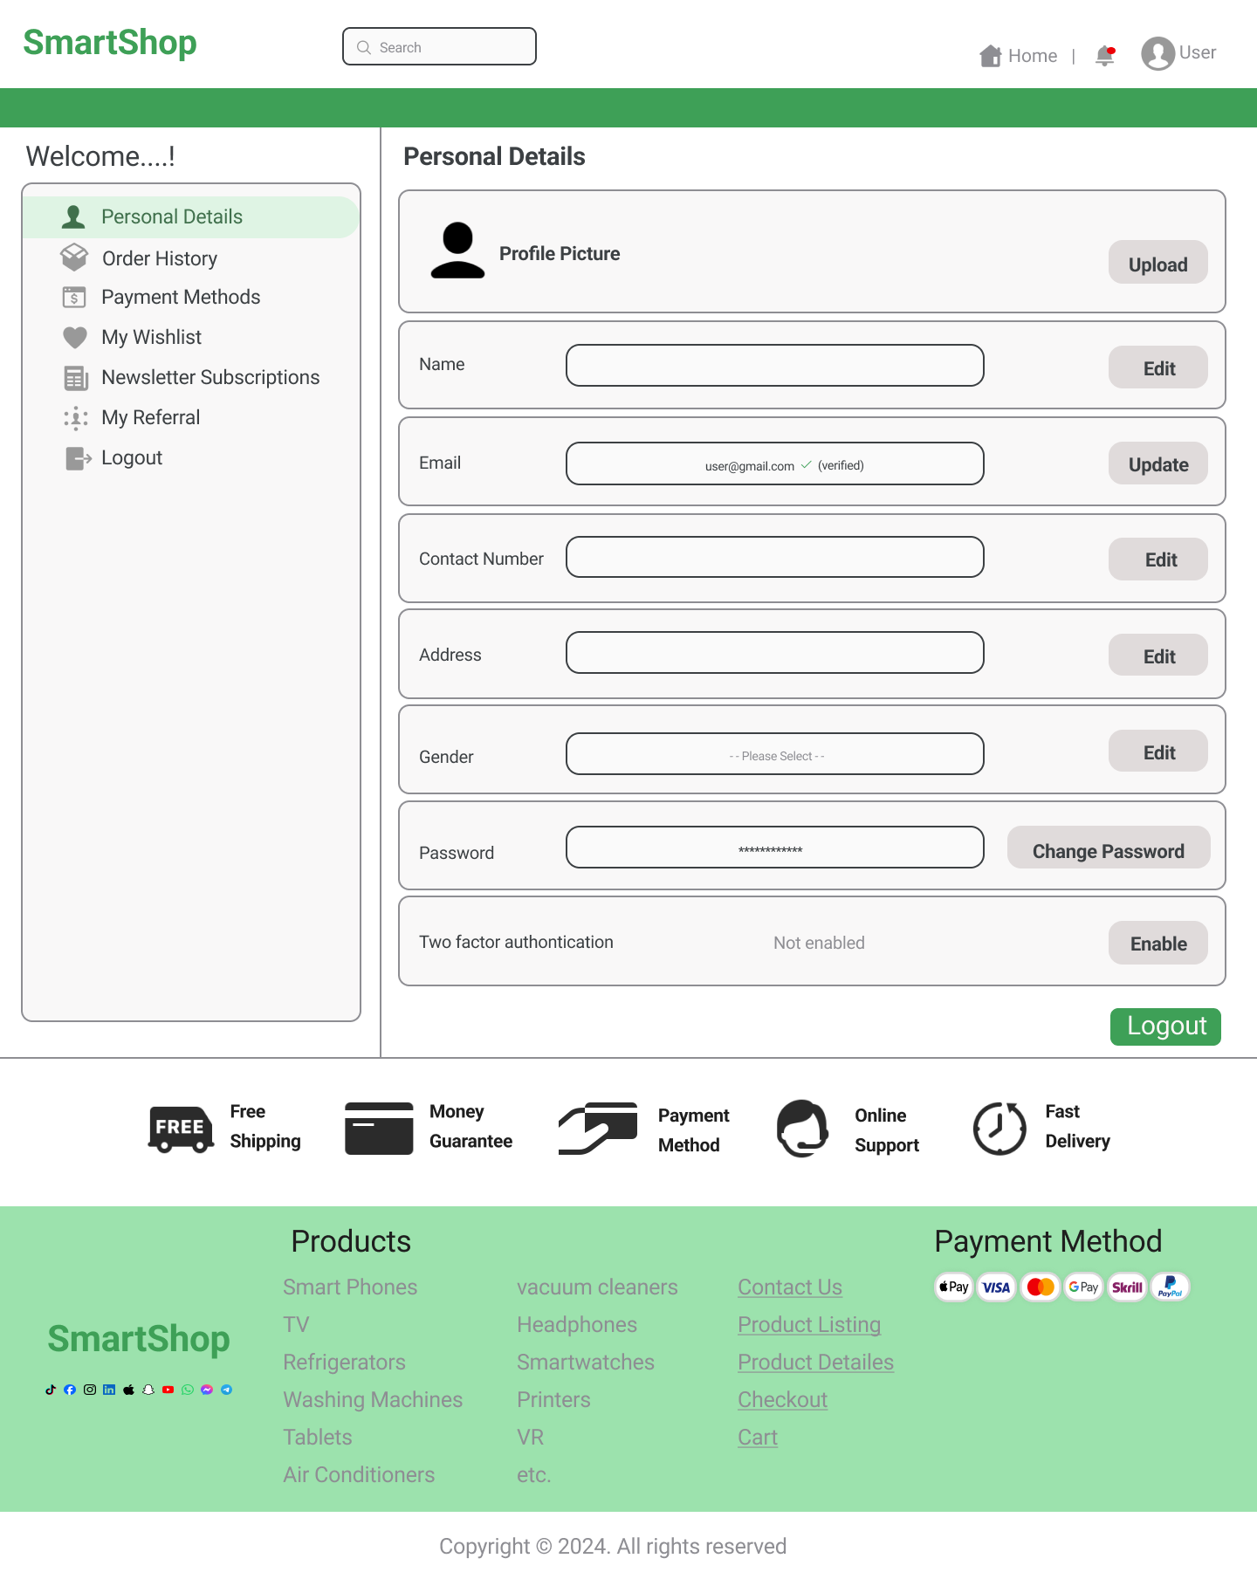

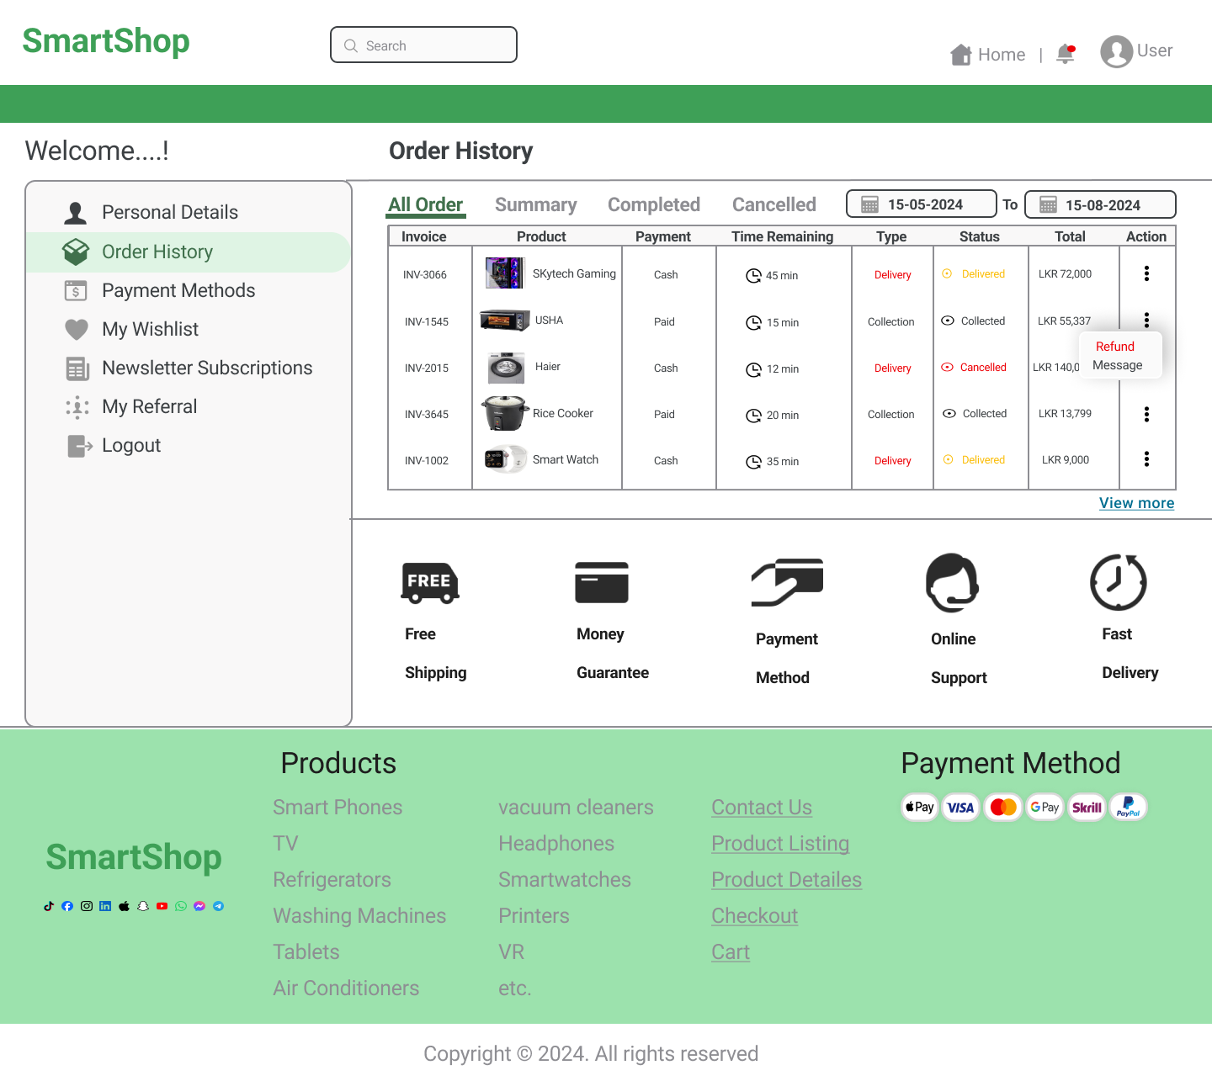

**Design:** Displays user information and order history. Includes options to edit profile information.

**Choice Rationale:** Allows users to manage their personal information and review their order history easily.

**Login Page**

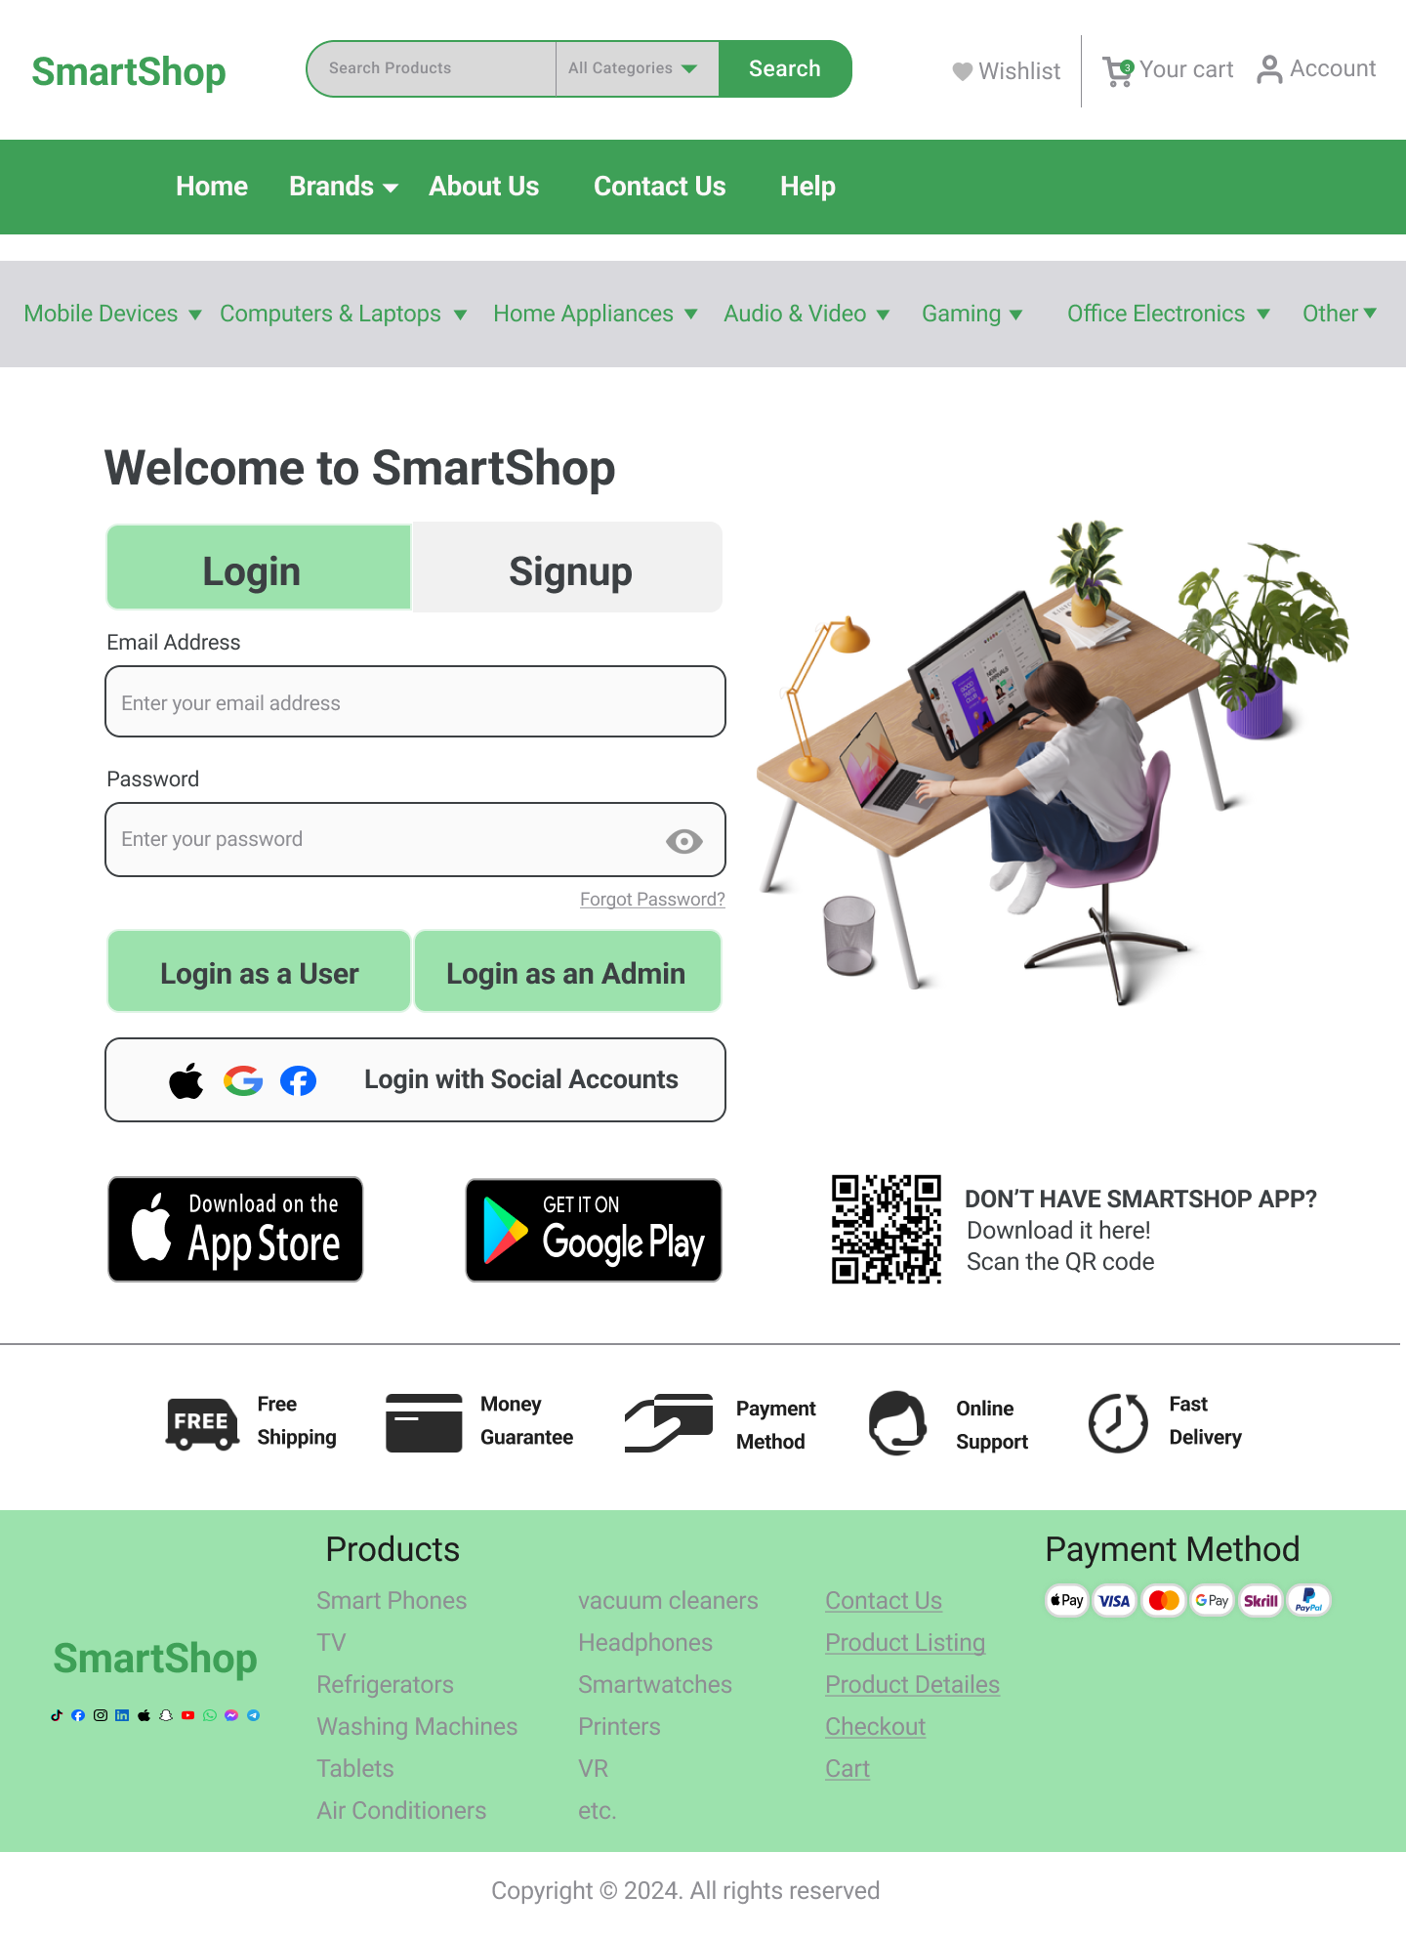

**Design:** Features a login form with email and password fields, a forgot password link, and navigation to the signup page.

**Choice Rationale:** Ensures secure and straightforward access to user accounts and admin accounts.

**Signup Page**

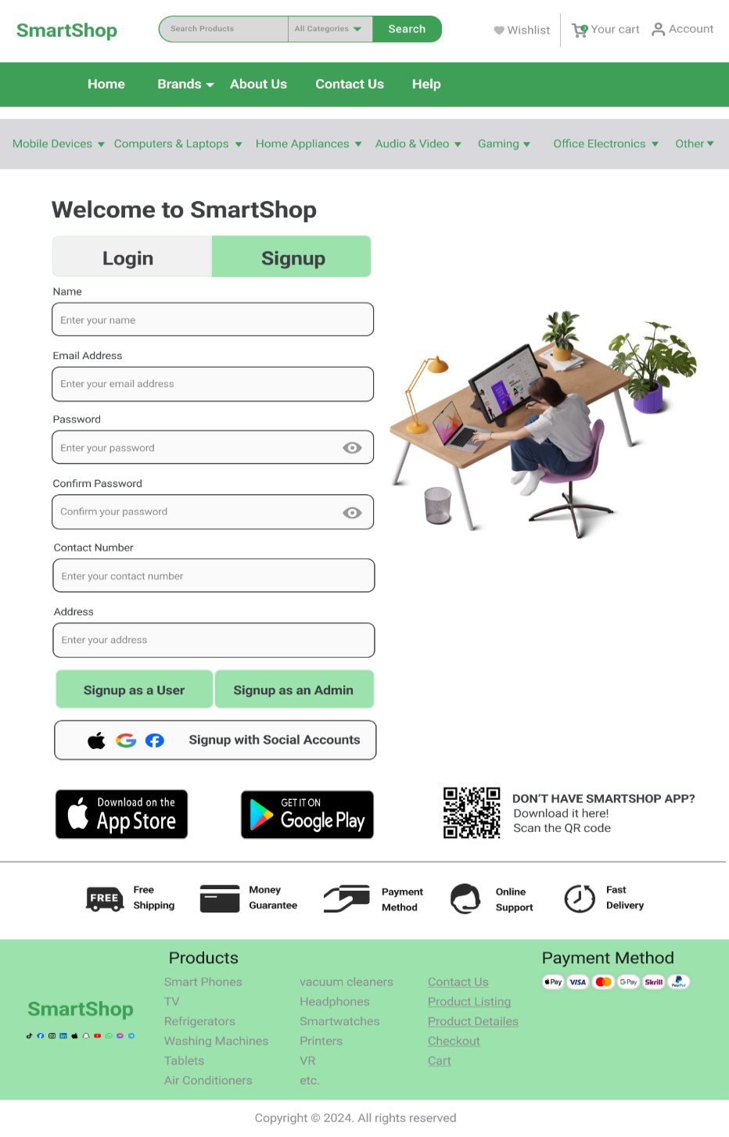

**Design:** Provides a registration form with fields for name, email, password, contact number, and address. Includes a link to the login page.

**Choice Rationale:** Facilitates easy user registration and admin registration with clear instructions and fields.

**Contact Us Page**

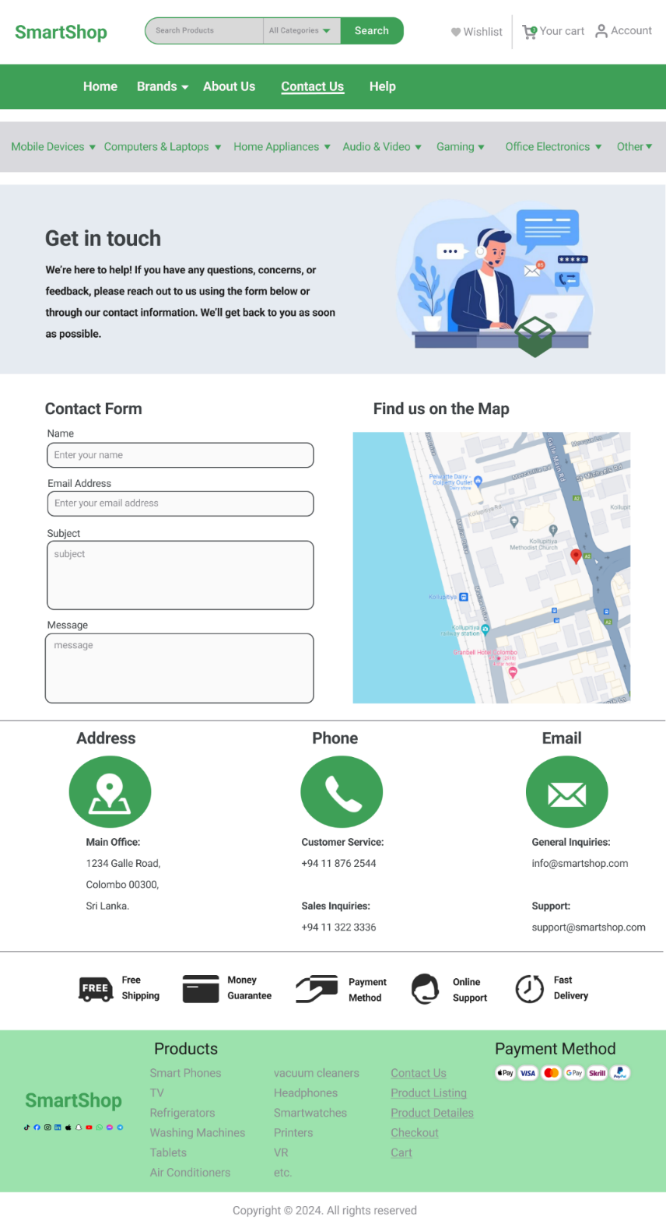

**Design:** Includes a contact form with fields for name, email, subject, and message. Shows the store address, contact information, and integrates a map to display the store location.

**Choice Rationale:** Offers a comprehensive way for users to contact the store and find its location.

**Responsive Design**

All pages in the design are deliberately built to be fully responsive, responding effortlessly to a wide range of devices such as Desktops, tablets, and mobile phones. The layout adapts automatically to multiple screen sizes, preserving both usefulness and visual appeal. Key design components like navigation menus, graphics, and text are optimized to provide consumers with an intuitive and engaging experience regardless of the device they are using. This responsiveness is critical in today's mobile-first environment, when customers expect seamless navigation across all devices. The design also takes into account touch interactions on mobile devices, making buttons, forms, and other interactive elements easy to access and operate. By focusing responsive design, the website not only boosts usability but also contributes to reaching a bigger audience, accommodating their preferred devices and improving overall satisfaction.

**Consistency**

The design uses fonts, colours, and other visual components consistently throughout all pages, giving the website a cohesive and professional impression. This consistency is critical in maintaining the corporate identity, making the website instantly identifiable and trustworthy. Uniformity in design components like headings, buttons, and icons ensures that users have a consistent and streamlined experience as they explore the site. The careful alignment of material, spacing, and graphics across all pages helps to create a professional and unified appearance. Consistent design also helps to reduce users' cognitive load, allowing them to focus on the information and functioning rather than being distracted by interface inconsistencies. By maintaining this level of consistency, the website not only looks aesthetically pleasing but also builds a strong, memorable brand presence that resonates with users, fostering brand loyalty and trust.

**Mobile Frame (iPhone 14&15 pro max)**

**User site Pages**

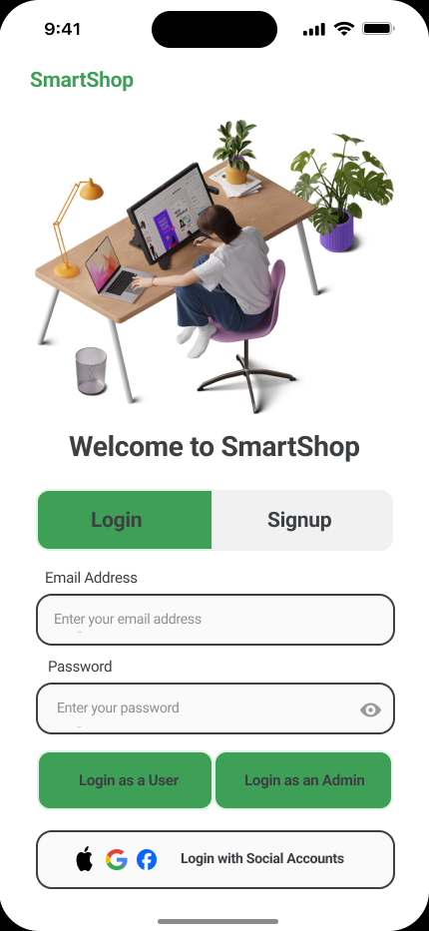

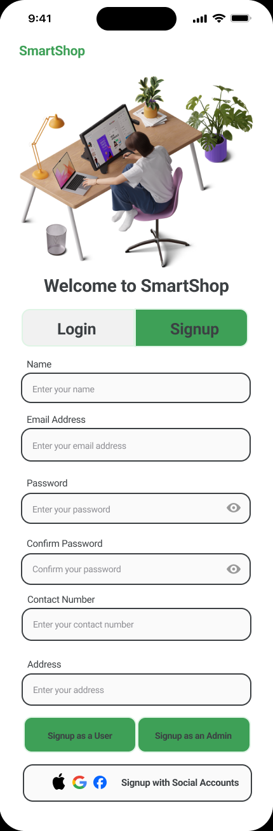

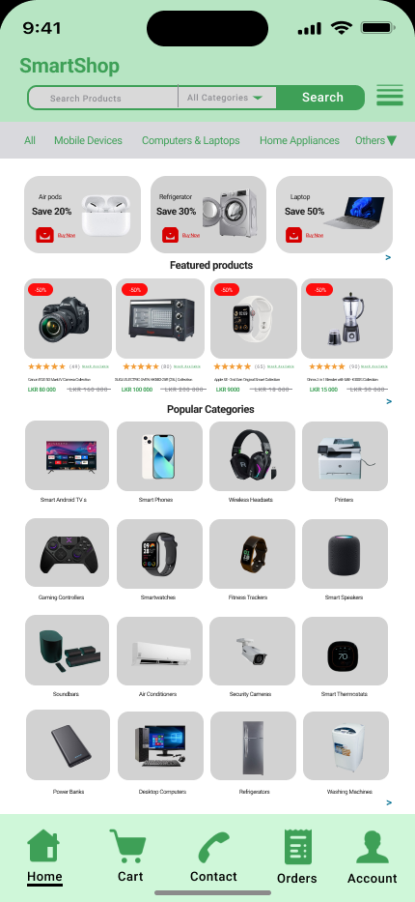

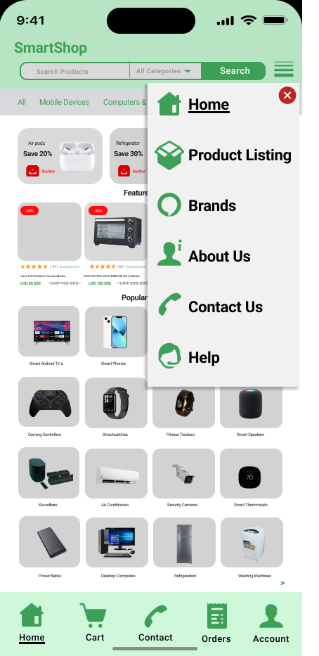

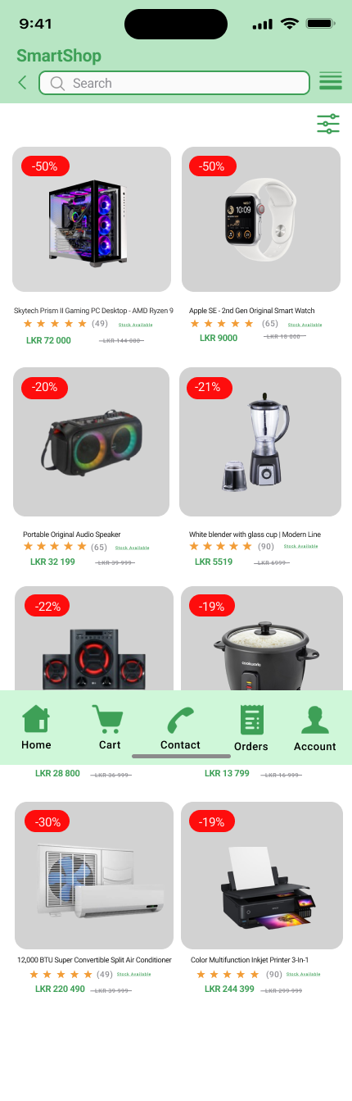

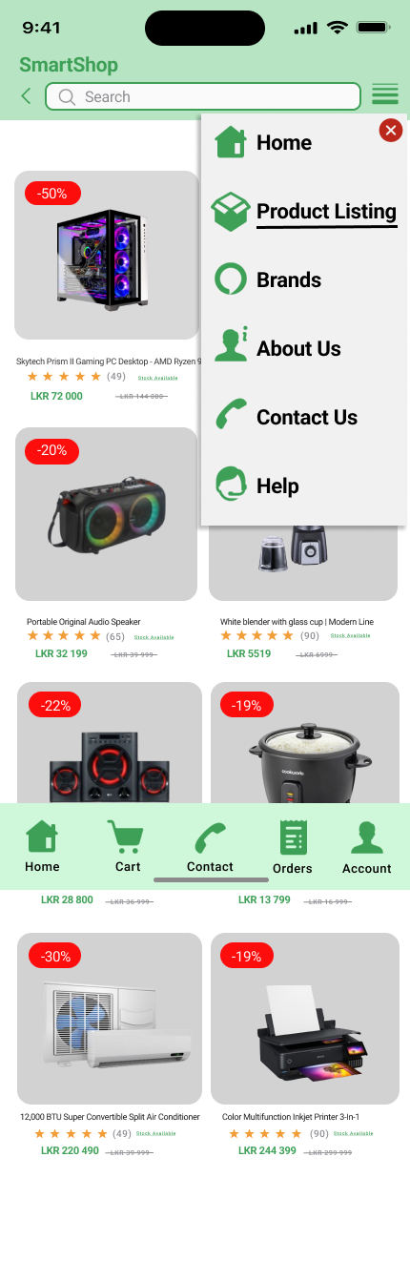

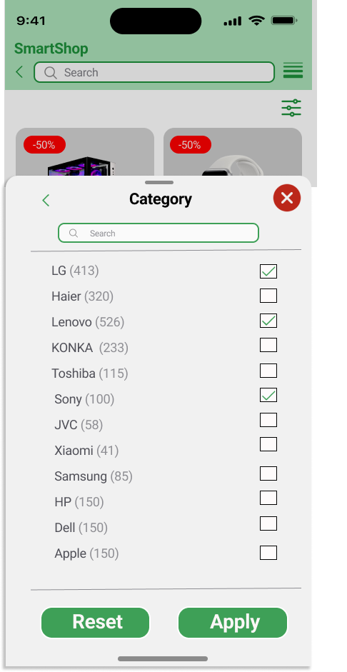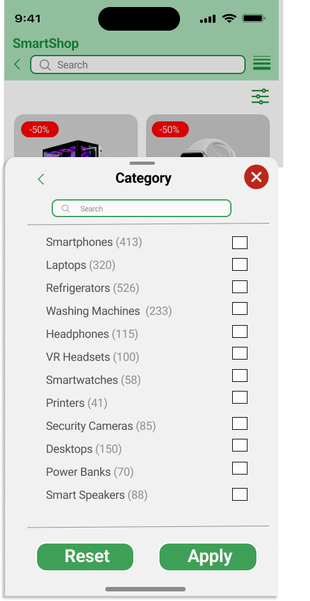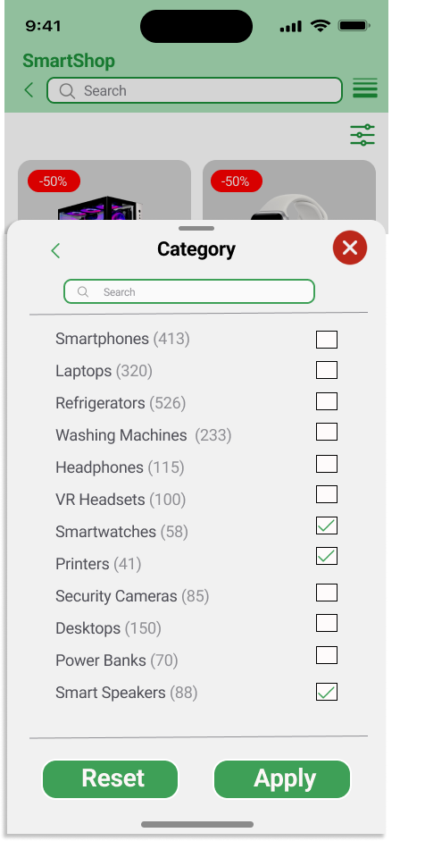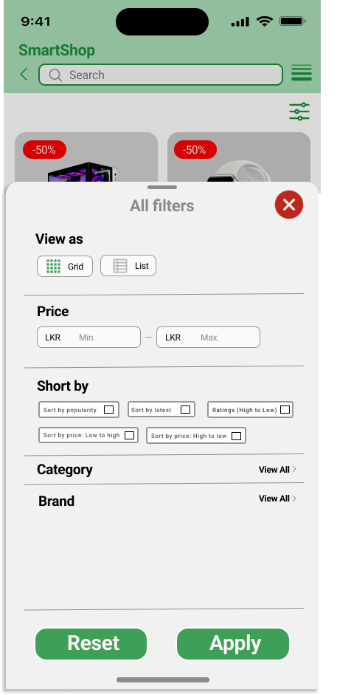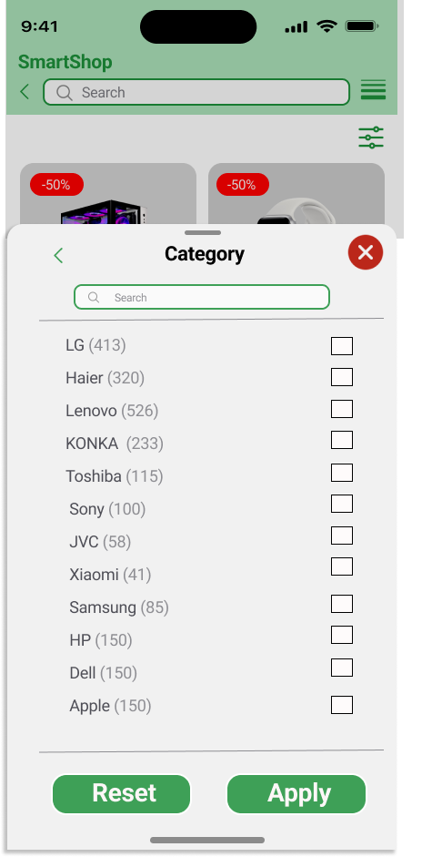

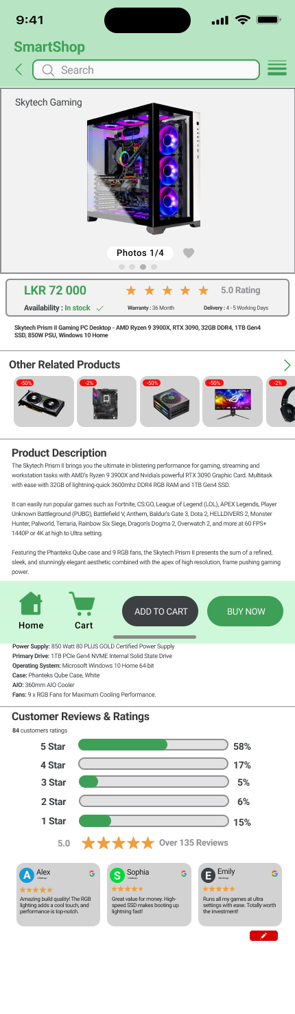

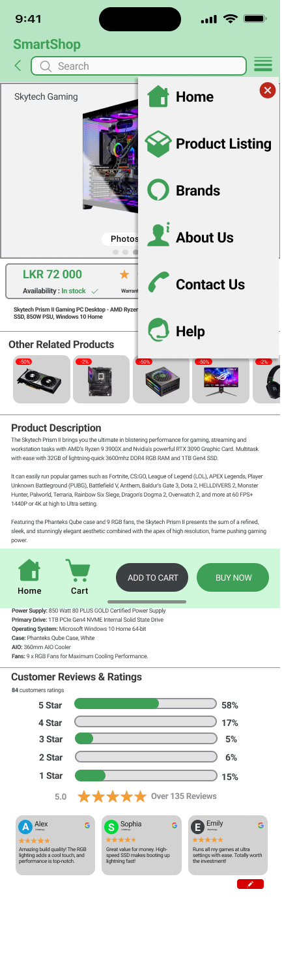





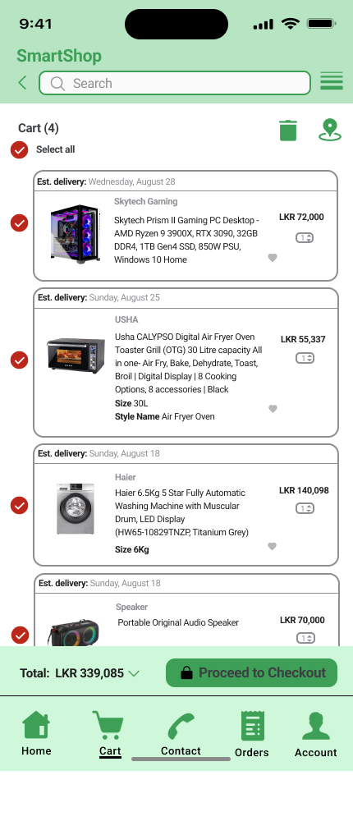

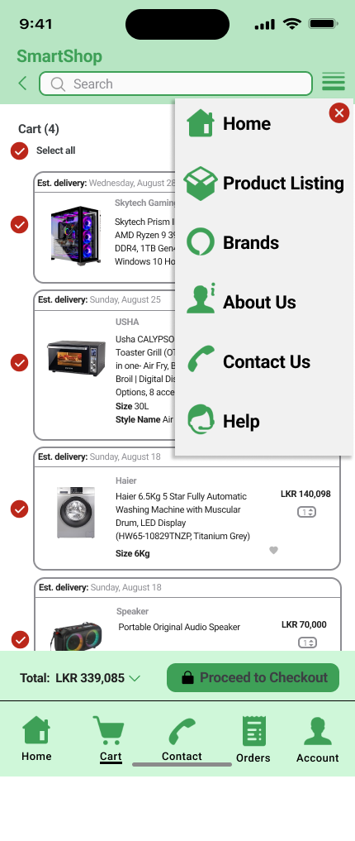

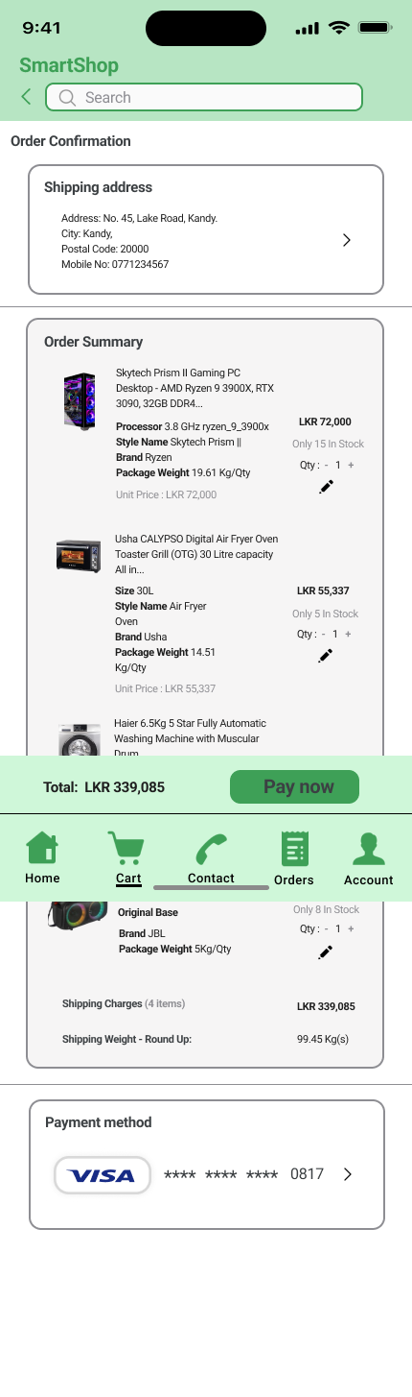

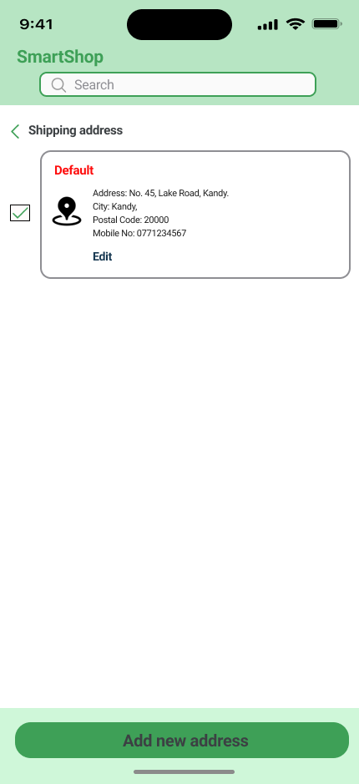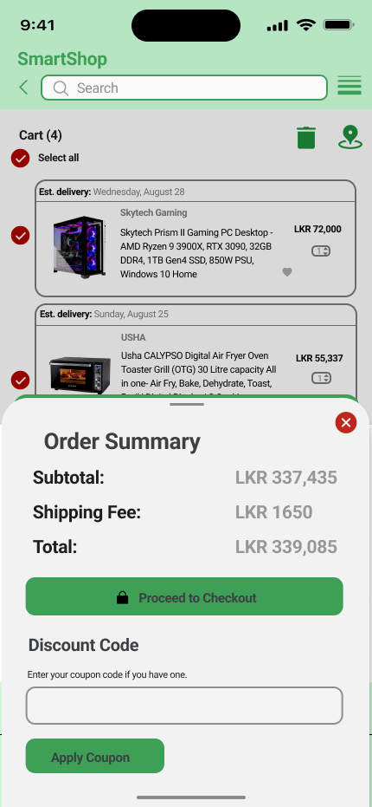

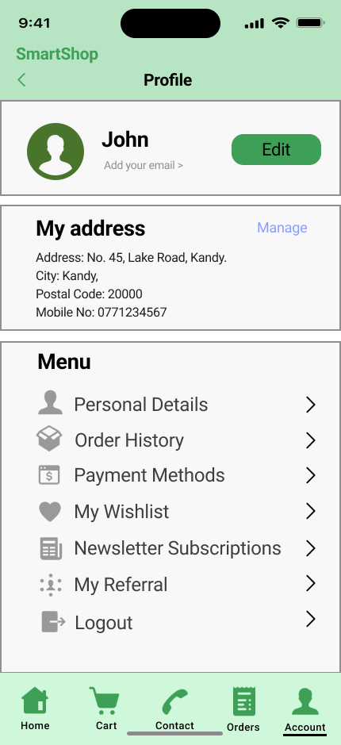

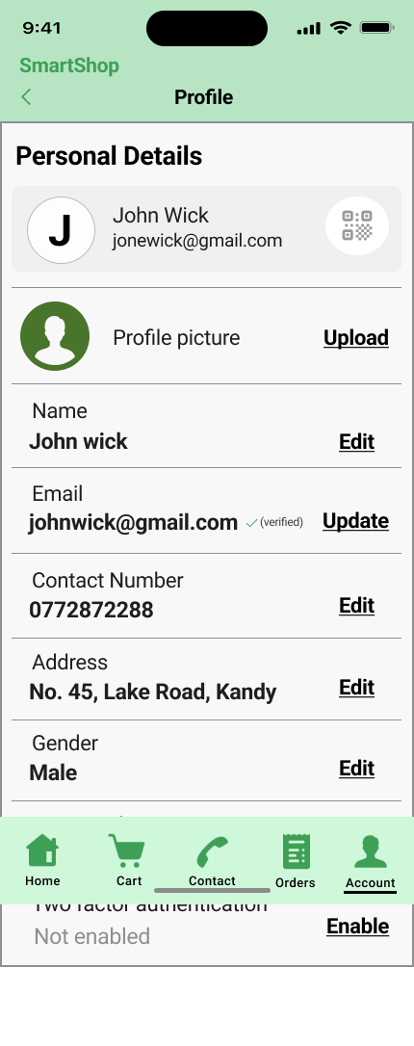

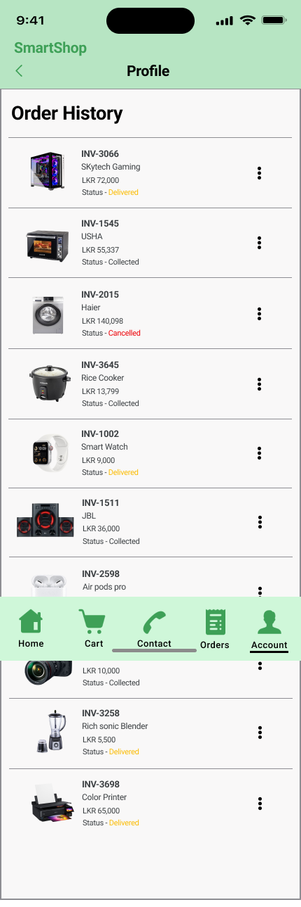

**Admin site Pages**

